**Paper 1 - Characterization of Tilapia Farming in Ghana: Descriptive Analysis of 400 Farmers**

Tilapia production systems 1:

1. Cage
2. Pond

Tilapia production systems 2:

1. Cage – tilapia only
2. Cage – mixed tilapia and catfish
3. Pond – tilapia only
4. Pond – mixed tilapia and catfish

Operational versus nonoperational

1. Active (including new farmers)
2. Inactive

Distance category – please check category based on the frequency tables

1. Next to home (0-100 meters)
2. 100m to 1 km
3. 1-10 km
4. 10-20 km
5. 20-30 km
6. . . . .

Summary tables to be produced:

1. Number and % of respondents by region, and by tilapia production system 1 (active only)
   * Then by distance category
   * Owner/manager as main respondent (which can be either manager or owner)
   * Manager and owner the same?

Not necessarily. An owner can manage the farm by himself then the owner is the manager; an owner can hire someone to manage the farm, in this case an owner is not the manager.

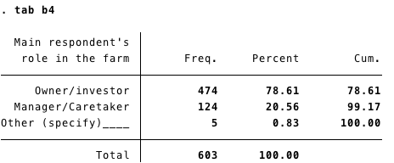

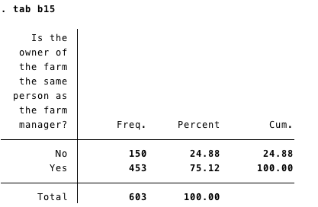

* + Gender of main respondent
  + Age of main respondent
  + Education level of main respondent
  + Distance of main respondent to farm
  + Religion of main respondent
  + Polygamous/monogamous as main respondent
  + Gender of manager
  + Age of manager
  + Education level of manager
  + Distance of manager to farm
  + Gender of owner
  + Age of owner
  + Education level of owner
  + Distance of owner to farm

1. Number of ponds (cages) per household (average, range)
2. Average and range of sizes/dimensions
3. Number and % of those with hatcheries; and average gram of fingerling produced
4. Months from stocking to last harvest (average, range) by tilapia production 1
5. Production (by m2, m3, kg)
6. Stocking rate
7. Survival rate
8. Those with hatchery – production in fingerling, survival rate, mortality, growth, etc.
9. Plans to increase/expand production - yes, no and please code and categorize the responses
10. Production increasing or decreasing – yes, no and please code and categorize the responses
11. History of fish farming
    * Where/from whom the learned about – please code and categorize the other (specify) responses
    * Did they seek advice – yes, no – and please code and categorize the other (specify) responses
    * Changes in the practices – series of yes and no – and please code and categorize these changes, and recommendations
    * Other questions here – please code and categorize the other (specify) responses
    * Crop farming – are most of the fish farmers also crop farmers - average crop acreage
    * Other livelihoods (land acreage, crops) (get a sense of how important aquaculture is in their livelihood mix)
12. Source of fingerling and everything in that section E, distance to fingerling source, if ARDEC/PAC, compute distance, if 999=don’t know, use the location/district of source given and roughly estimate distance
13. All questions on the certified source – starting with e43
14. Everything on the perceptions of quality – all inputs, distributed across different modules
15. Everything that has to do with having/keeping records
16. Fixed and variable costs per m2, m3 and kg
17. Profits – total harvest value X average price – costs (by m2, m3, and kg)
18. Main buyers
19. All of section K (rating of facilities)
20. Asset – how well-off or poor are the respondents
21. Access to credit (for aqua, and other activities)
22. Sources of information or extension services
23. Groups/associations/social networks
24. Assistance/support/programs/projects

For inactive:

1. Reasons for not continuing tilapia farming (a03_i) – please code and categorize the responses
2. And all other tables above, where the inactive ones have responses

Gender dimension

1. Summarize all of section J, differentiating female and male (all, then by region, then by cage/pond)
2. WEAI score for female and male, and difference in WEAI score of female and male within household
3. Gender attitudes

**Paper 2 – Modeling tilapia farm productivity and efficiency (need to consider structural endogeneity, etc.)**

Outcome variables:

1. Production (per m2, m3 and kg)
2. Survival rate
3. Profit (per m2, m3, kg)
4. Growth performance and mortality (for hatcheries)

Explanatory variables:

1. Quantity and value of fingerling (pieces, and GHS)
2. Quantity and value of feeds (kg and GHS)
3. Commercial feeds versus on-farm production (0/1)
4. Labor, hired and family (person-days)
5. Use of drugs/hormones (0/1)
6. Have records (0/1, and count)
7. Index of facility rating
8. Perception questions (index perhaps)
9. Socioeconomic variables
   1. Asset quintile
   2. Gender, age, educ of owner/manager
   3. Access to extension
   4. Access to credit
   5. Access to projects/programs
   6. Distance to source of fingerling
10. GIS variables

**Paper 3 – Gender**

**Paper 4 – Characterizing farmers’ current practice, experience and demand for quality fingerings (factors; willingness to pay; demand for certification; etc.)**